RWD dog for adoption ads – via WordPress

When an owner fills in an Application to Submit a Dog for Adoption on the website, an ad draft is generated and you are alerted via email, with a link to take you to the ad draft.

The key points when editing the ad are to:

- Check spelling and grammar, and alter any phrases that might be considered controversial (e.g. he can be a prick when there’s a bitch in heat – this was an actual comment!)
- Edit the photo if required: the photo may need to be rotated and/or cropped so it is in landscape orientation – otherwise the photo doesn’t look the best on Facebook.
- Make sure the “Portfolio Type” tags on the side bar are ticked appropriately: i.e. North Is vs South Is, male vs female etc.
- Make sure the contact details for the owner look right e.g. email address domain spelt correctly
- Once you’re happy with the ad, click publish. Then copy and paste the permalink to the Facebook page.

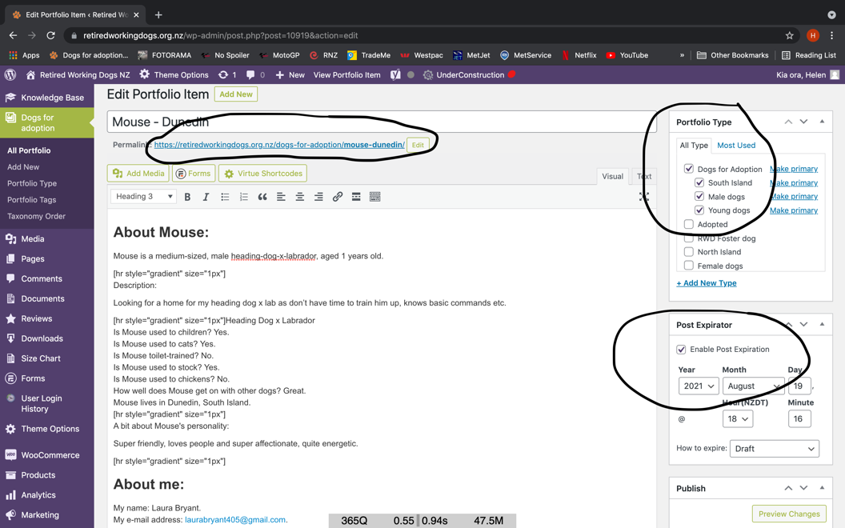

Done! When a dog is adopted, edit the ad to include ADOPTED in front of their name on the headline (ADOPTED Mouse – Dunedin), tick the Adopted tag (under Portfolio Type), and untick the other tags – male, North Is etc.

The ads have a post expiry function – they will expire to draft form after one month. If an owner gets in touch to say their dog still needs a home, you can edit the post expiry manually, then republish.

If an owner wants to add more photos, go to Portfolio Post Options:
Under Project Options, select Image Slider: Cropped Image Ratio
Click Add/Edit Gallery
Photos can be uploaded or dragged and dropped into here, then select as many as required.
On the side bar, select a Featured Image – this is the main photo, and the one that appears on Facebook.

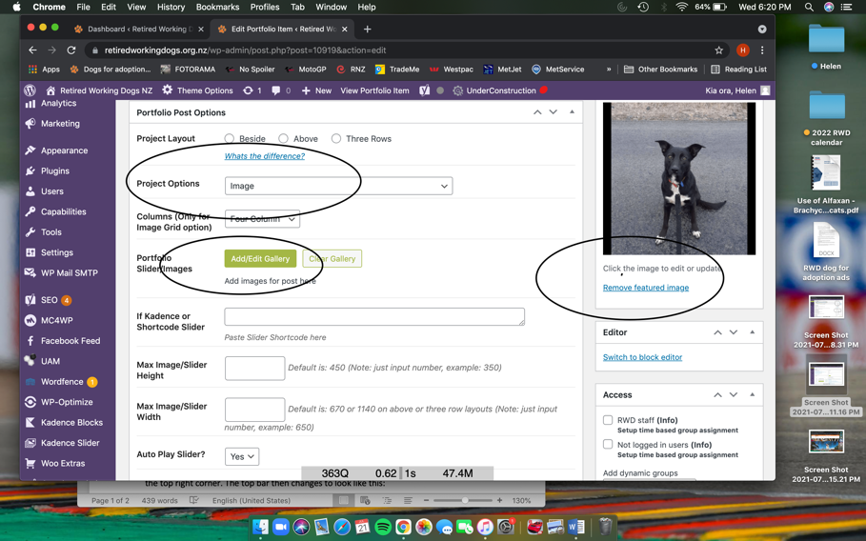

If you need to reply to an owner before publishing the ad – e.g. on editing there are some inconsistencies, or their dog is a breed we don’t advertise – then clicking ‘reply’ to the email notifying you of their ad will reply to the owner’s email.

You can access any of the ads via the website as well – log on via the Staff Only button, in the top right corner. The top bar then changes to look like this:

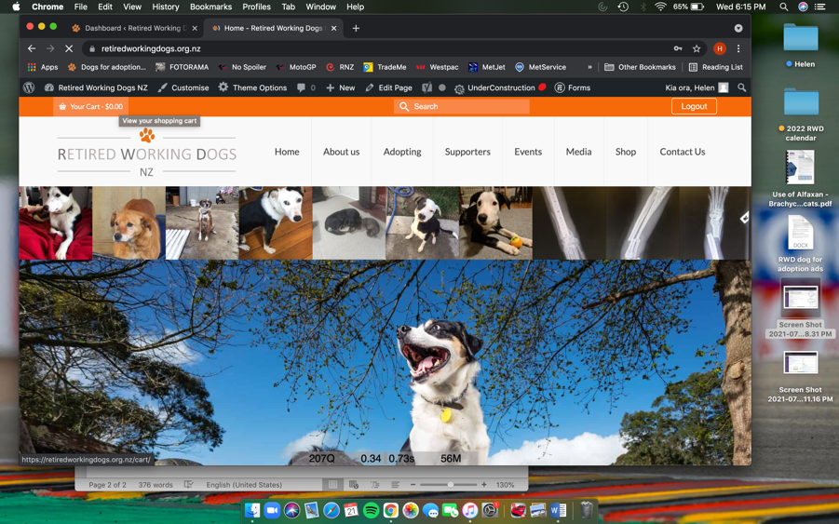

Click on the Retired Working Dogs NZ next to the speedometer sign (top left, on the black header bar), select Dashboard, and it will take you to:

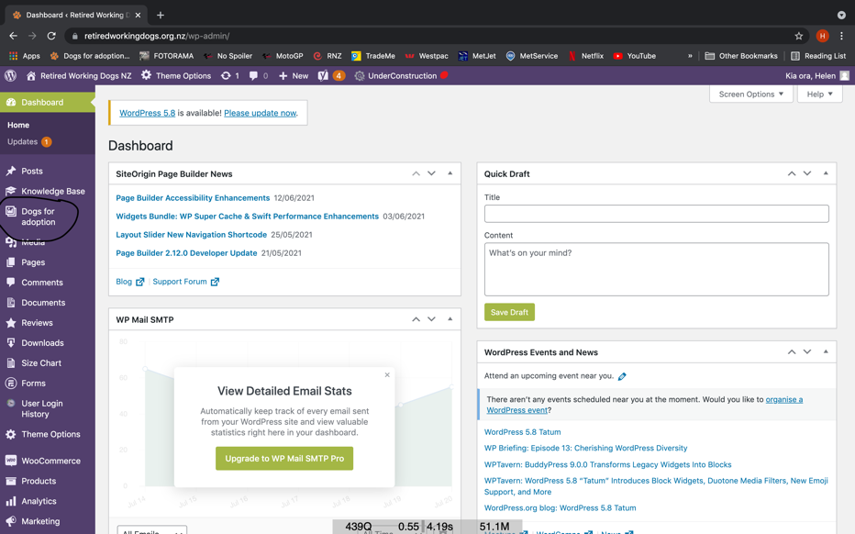

Click on Dogs for Adoption on the left side bar (circled above) then All Portfolio. From here you can search for any dog that has been advertised.

